Tealen Davis

Dr Sanders

ITEC 325 - 101

14 May 2023

# NAME OF PROCEDURE: Windows 10 Pro Installation

# PRINCIPLE

**The purpose of a Standard Operating Procedure (SOP) for Windows 10 Pro Installation is to provide the step-by-step process of a clean install of Windows 10 on your computer. Whether you are upgrading from an earlier version of Windows or switching from a different operating system altogether, this guide will provide you with the information you need to successfully install Windows 10 on your device. So, let's get started!**

# SPECIMEN

# Popular operating system Windows 10 was created by Microsoft Corporation. It succeeded Windows 8.1 and was originally made available in July 2015. Windows 10 is made to function on a range of gadgets, such as desktops, laptops, tablets, and smartphones. A revamped Start menu, the Microsoft Edge web browser, the Cortana personal assistant, and different productivity tools are just a few of the features and programs that come with it. Microsoft also releases security updates and new features for Windows 10 on a regular basis to enhance its performance and functionality. With an estimated 1.3 billion active devices using Windows 10 as of 2021, it has grown to be one of the most popular operating systems worldwide.

# PROCEDURE

This tutorial could be used for upgrading your PC but also applies to installations that involve virtual machines. There are three main steps in OS installation in regards to virtual machines:

### Download OS installation files

### Install the OS as virtual machine in VMware Workstation

### Power On the VM and complete the basic setup for each OS

At this point, if you plan to use a virtual machine, you should download and install VMware Workstation from the VMware website before installing the ISO file. It’s a quick, simple and free process. It allows you to set up multiple operating systems all on one laptop. There’s a lot of cool features you can do with it. There are many benefits, but in this SOP it’ll only show you how to create a single virtual machine for Windows 10 Pro.

You should familiarize yourself with the layout of VMware Station and Windows 10’s graphical interface if you haven’t already.

Watch: *Getting Started with Windows 10* at <https://www.youtube.com/watch?v=fcBZCSs9IrQ> and *you need to learn Virtual Machines RIGHT NOW!! (Kali Linux VM, Ubuntu, Windows)* at https://www.youtube.com/watch?v=wX75Z-4MEoM

## Obtain the Windows 10 ISO file

You can obtain the file on the Microsoft website at <https://www.microsoft.com/en-us/software-download/windows10> . Click the “Download Now” button and the ISO file will now begin to download to your computer. Once completed, you can use the ISO file to create a bootable USB drive/DVD or use it as a reference for the VMware Workspace.

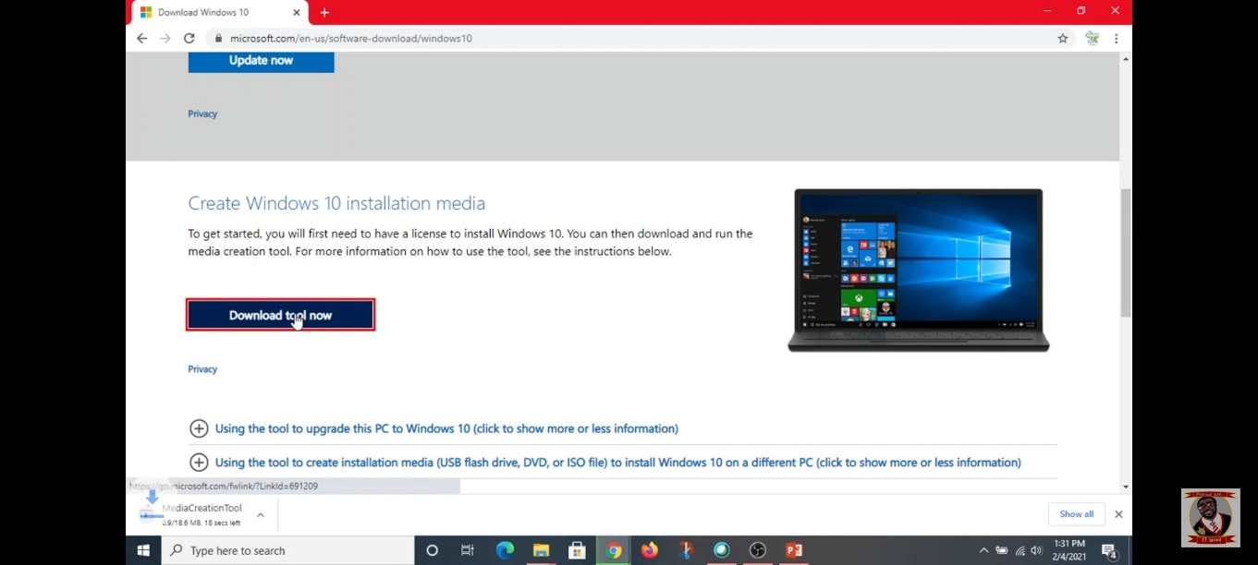

### First you want to open your VMware Station software on your computer.

### Second thing you want to do is select the "Create a New Virtual Machine" button to create a new virtual machine.

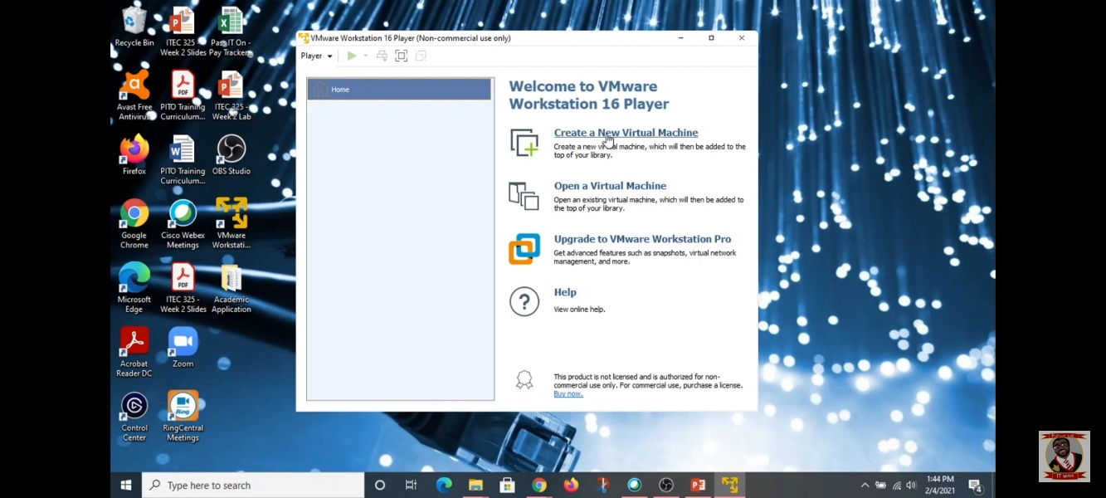

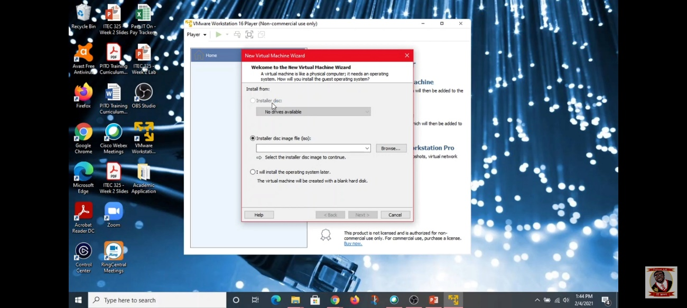

### Next, in the "New Virtual Machine Wizard," you want to select the "Installer disc image file (ISO)" option and then click on the "Next" button.

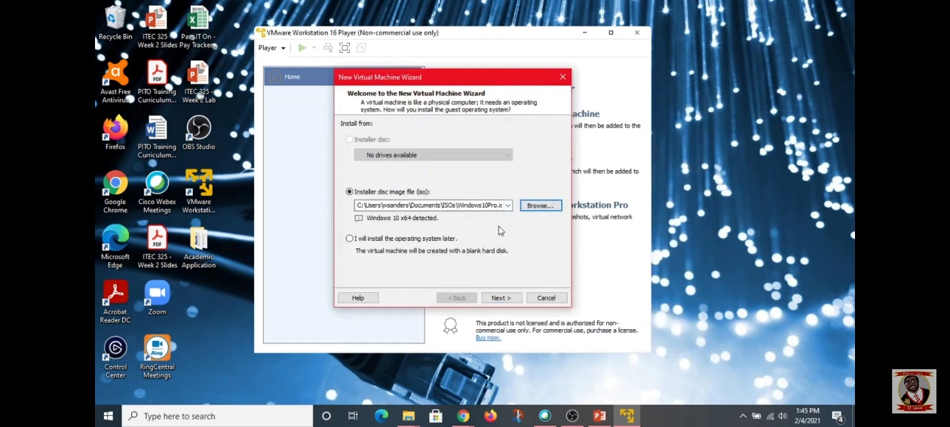

### Locate the Windows 10 Pro ISO file by clicking the "Browse" button.

### To proceed, click the "Next" button.

### Make your selection and press "Next" to install the guest operating system.

### Enter the virtual machine's name and location, then click "Next".

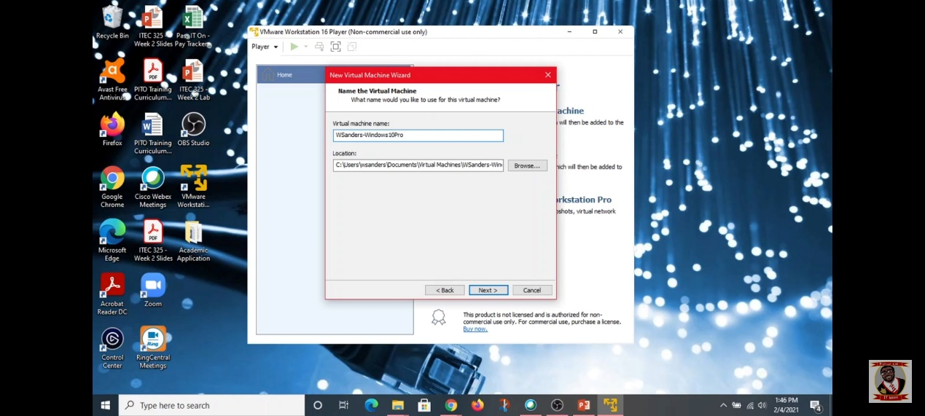

### Select the virtual machine's disk capacity(default is recommended) and press the "Next" button.

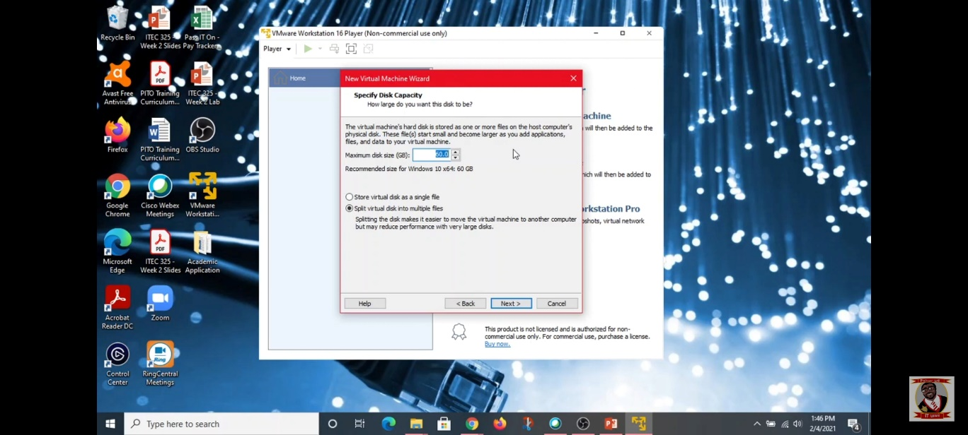

### After checking the virtual machine's settings, click "Finish" to start the virtual machine.

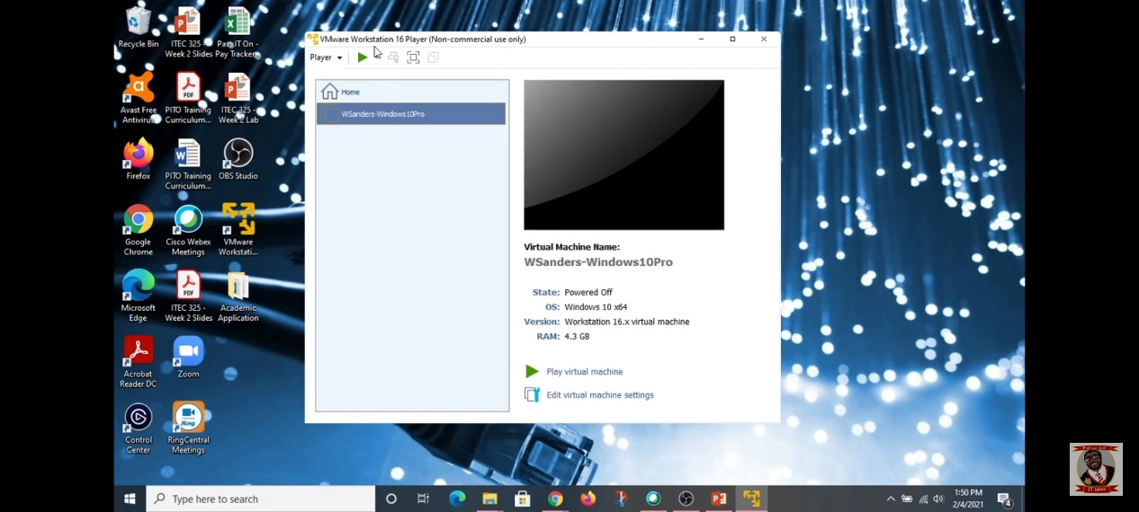

## Create a bootable USB drive/DVD (skip this part if you want to run an ISO file in a virtual machine)

## Insert the bootable USB/ DVD into your computer

## Boot from the USB or open your Virtual Machine and select your newly created Windows 10 Pro operating system